**Create Spring Application using RestAPI**

1. Create Maven Project for Spring application using RestAPI
2. Create the pom.xml file
3. Create Jsp file under the Maven-> **Main** folder(right click) create a new folder with **webapp**
4. Create a Controller class

**1.Create Maven Project for Spring application using RestAPI**

<?xml version=*"1.0"* encoding=*"UTF-8"*?>

<project xmlns=*"http://maven.apache.org/POM/4.0.0"* xmlns:xsi=*"http://www.w3.org/2001/XMLSchema-instance"*

xsi:schemaLocation=*"http://maven.apache.org/POM/4.0.0 https://maven.apache.org/xsd/maven-4.0.0.xsd"*>

<modelVersion>4.0.0</modelVersion>

<parent>

<groupId>org.springframework.boot</groupId>

<artifactId>spring-boot-starter-parent</artifactId>

<version>2.3.5.RELEASE</version>

<relativePath/> <!-- lookup parent from repository -->

</parent>

<groupId>com.example</groupId>

<artifactId>SpringMVCDemo</artifactId>

<version>0.0.1-SNAPSHOT</version>

<name>SpringWithXmlExample-1</name>

<description>Demo project for Spring Boot</description>

<properties>

<java.version>1.8</java.version>

<maven-jar-plugin.version>3.1.1</maven-jar-plugin.version>

</properties>

<dependencies>

<dependency>

<groupId>org.springframework.boot</groupId>

<artifactId>spring-boot-starter-web</artifactId>

</dependency>

<dependency>

<groupId>org.springframework.boot</groupId>

<artifactId>spring-boot-starter-tomcat</artifactId>

<scope>provided</scope>

</dependency>

<dependency>

<groupId>org.springframework.boot</groupId>

<artifactId>spring-boot-devtools</artifactId>

<scope>provided</scope>

</dependency>

<dependency>

<groupId>org.apache.tomcat.embed</groupId>

<artifactId>tomcat-embed-jasper</artifactId>

<scope>provided</scope>

</dependency>

<dependency>

<groupId>javax.servlet</groupId>

<artifactId>jstl</artifactId>

</dependency>

<dependency>

<groupId>mysql</groupId>

<artifactId>mysql-connector-java</artifactId>

<scope>runtime</scope>

</dependency>

<dependency>

<groupId>org.springframework.boot</groupId>

<artifactId>spring-boot-starter-test</artifactId>

<scope>test</scope>

<exclusions>

<exclusion>

<groupId>org.junit.vintage</groupId>

<artifactId>junit-vintage-engine</artifactId>

</exclusion>

</exclusions>

</dependency>

<dependency>

<groupId>org.springframework.boot</groupId>

<artifactId>spring-boot-starter-data-jpa</artifactId>

</dependency>

<dependency>

<groupId>org.springframework.boot</groupId>

<artifactId>spring-boot-starter-validation</artifactId>

</dependency>

</dependencies>

<build>

<plugins>

<plugin>

<groupId>org.springframework.boot</groupId>

<artifactId>spring-boot-maven-plugin</artifactId>

</plugin>

</plugins>

</build>

</project>

**2.welcome.jsp**

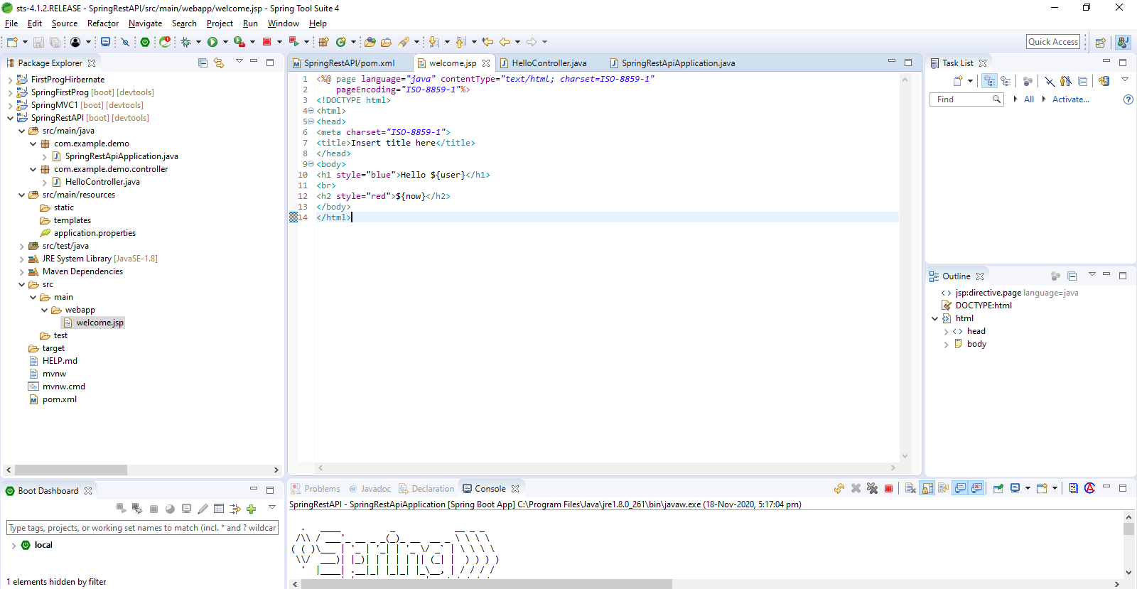

<%@ page language=*"java"* contentType=*"text/html; charset=ISO-8859-1"*

pageEncoding=*"ISO-8859-1"*%>

<!DOCTYPE html>

<html>

<head>

<meta charset=*"ISO-8859-1"*>

<title>Insert title here</title>

</head>

<body>

<h1 style="blue">Hello Welcome to RestAPI ${user}</h1>

<br>

<h2 style="red">${now}</h2>

</body>

</html>

**3.Create HelloController class**

**package** com.example.demo.controller;

**import** java.time.LocalDateTime;

**import** org.springframework.stereotype.Controller;

**import** org.springframework.ui.ModelMap;

**import** org.springframework.web.bind.annotation.RequestMapping;

**import** org.springframework.web.bind.annotation.RequestParam;

@Controller

**public** **class** HelloController {

@RequestMapping("/show")

**public** String showPage(@RequestParam(name = "user", required = **false**) String user, ModelMap model) {

**if** (user == **null**) // if no parameter is passed

model.put("user","Guest");

**else**

model.put("user", user);

model.put("now", LocalDateTime.*now*().toString());

**return** "welcome";

}

}

**4.SpringRestApiApplication.java**

**package com.example.demo;**

**import org.springframework.boot.SpringApplication;**

**import org.springframework.boot.autoconfigure.SpringBootApplication;**

**@SpringBootApplication**

**public class SpringRestApiApplication {**

**public static void main(String[] args) {**

**SpringApplication.run(SpringRestApiApplication.class, args);**

**}**

**}**

**Output:**

**Open browser and type the link** localhost:8888/show?user=Sandeep Singh

